Step 1: Fix the hello-world App Deployment

* Access:

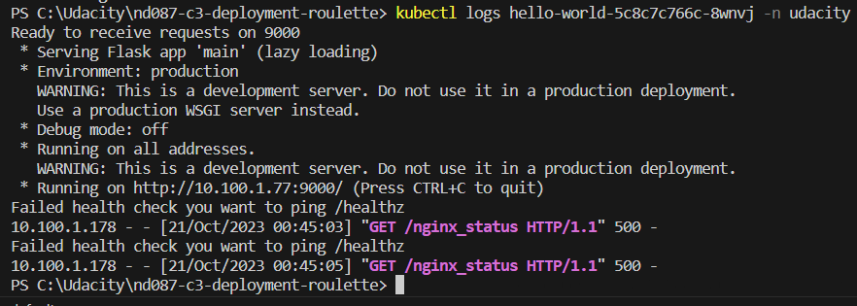

* Identify:

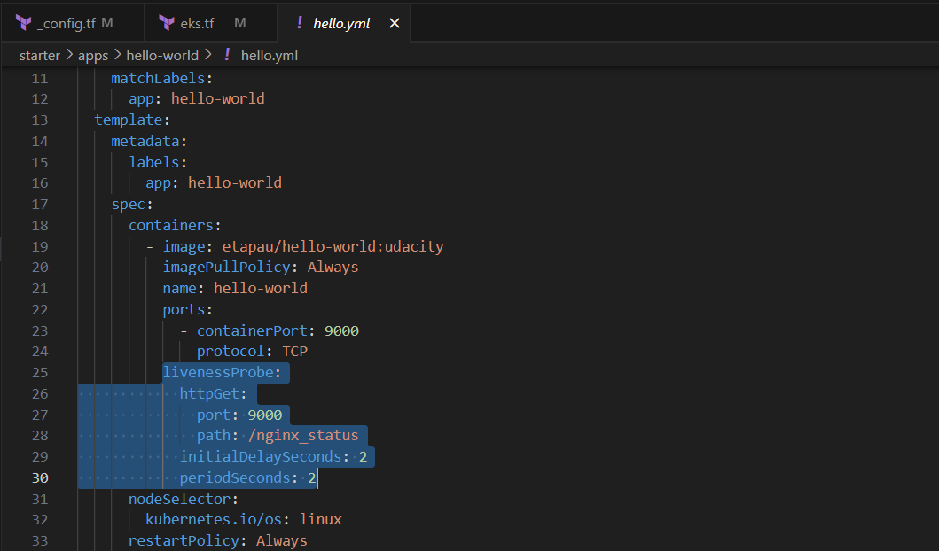

The problem is with livenessProbe

* Solve:

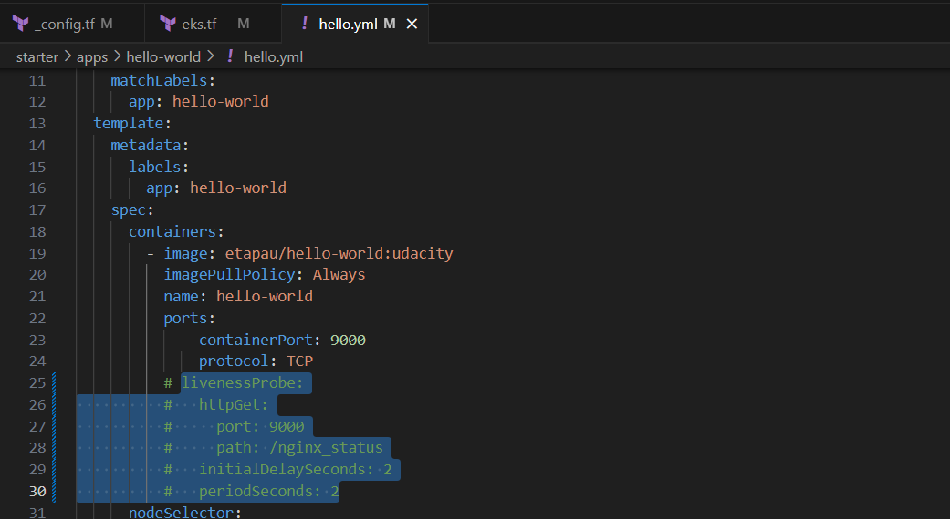

Comment out the source of the issue

* Final result:

